**Group12**

Choi Ka Chon 1155051770

HUANG Chuanshan 1155076957

Siu Pong Yin 1155062979

Wong Chak Shun 1155061036

**Project:** AntiSlime

**Build Instruction**

**Platform:** Unity 2017.2 - PC, Mac & Linux Standalone <OpenGL 4.1>

**Remark:** The game world can be opened in the below path.

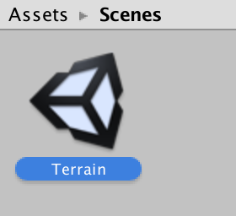

**User guide**

**Briefing:** We have designed a low-poly island. In the stage, player needs to use ammo of different elements and destroy different types of slimes. In order to clean the stage, player has to kill the slime boss.

**Game Flow:**

1. First comes to the starting interface, where players can choose either to enter the game or quit.

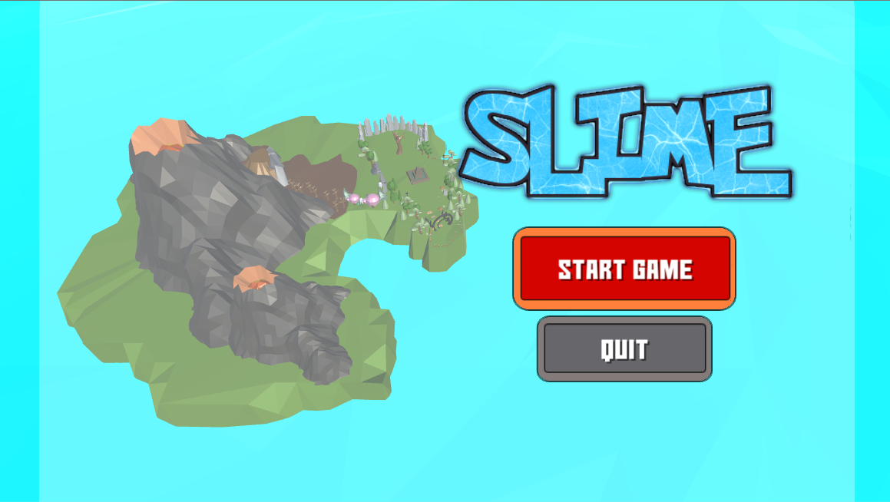

b. After the players enter the game, they can pick up the level

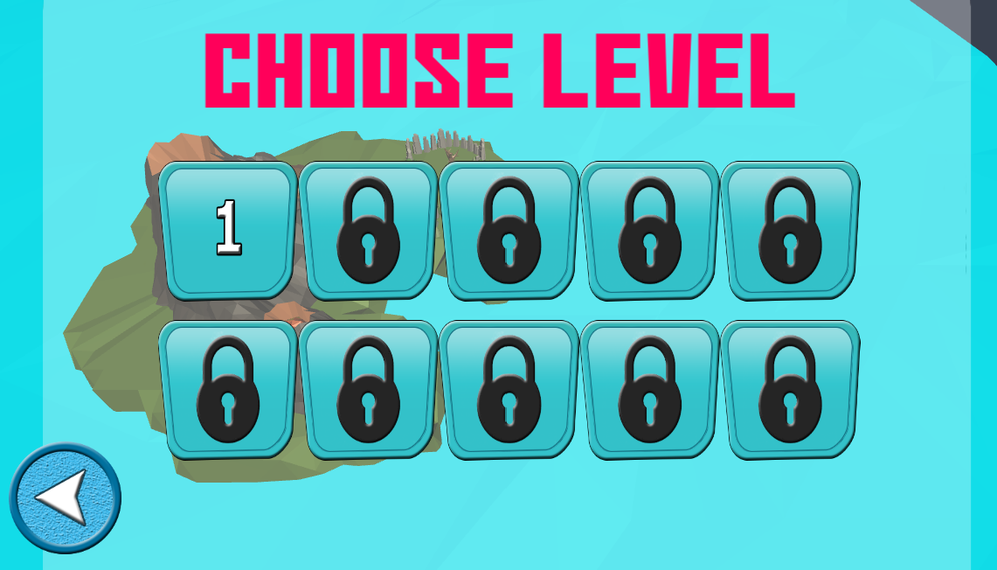

c. Game started

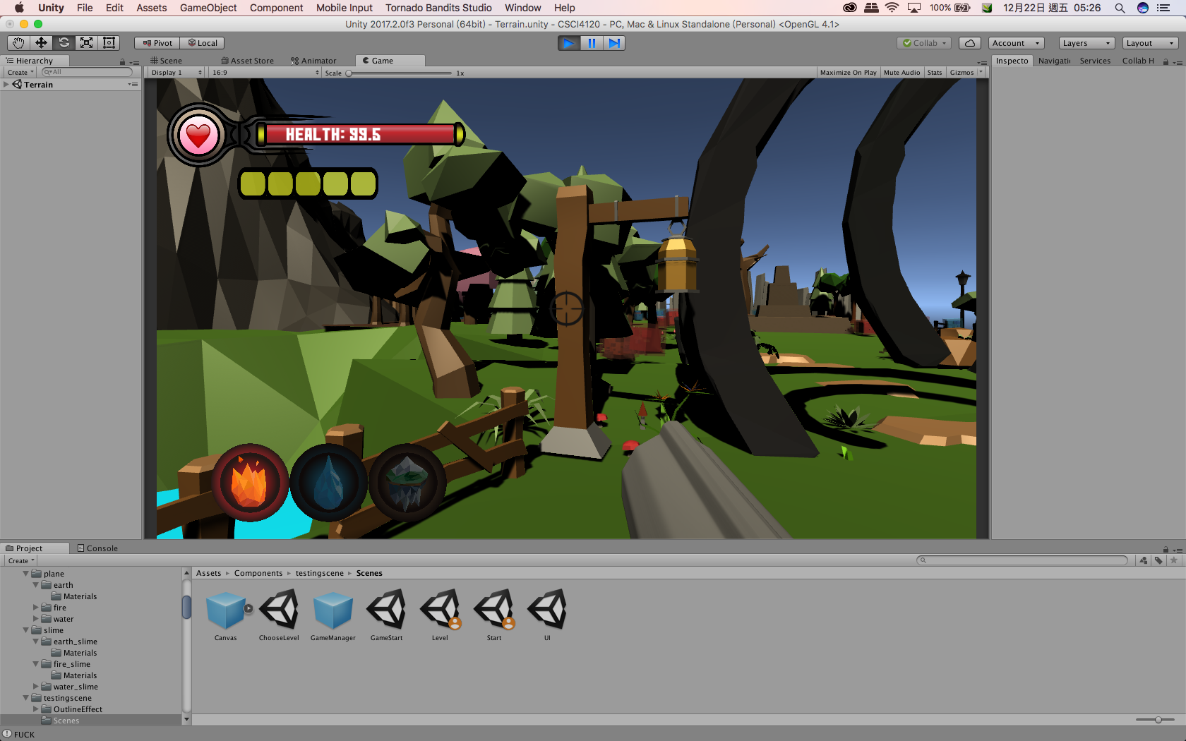

d. Growing a slime when used the wrong bullet.

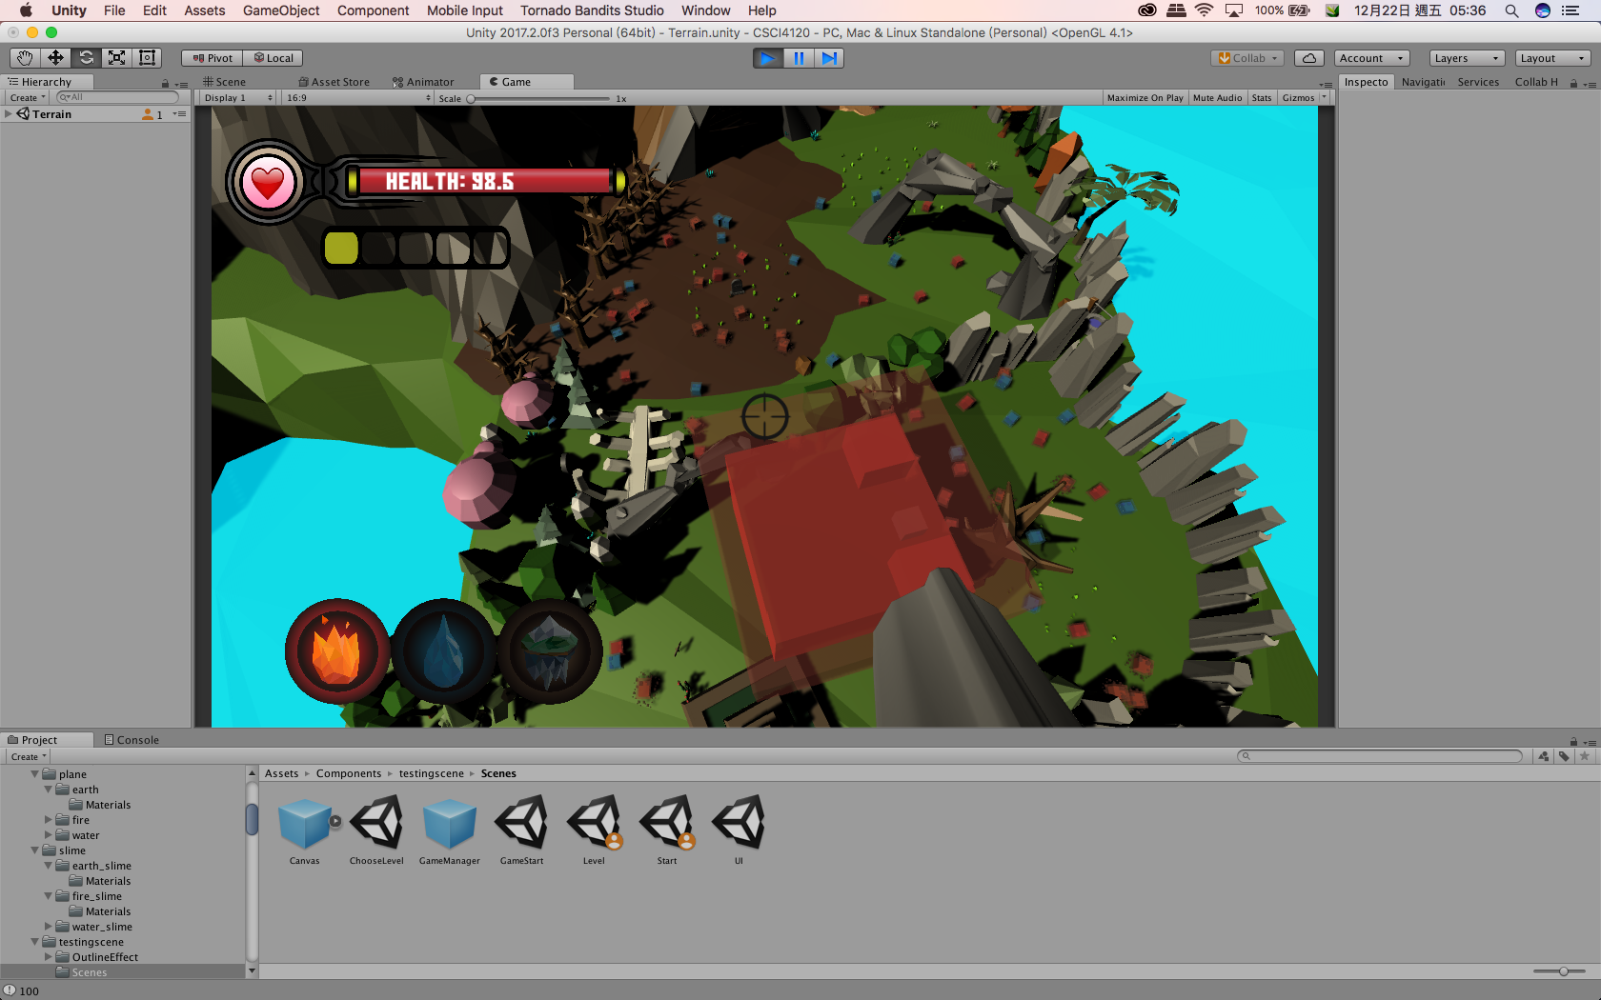

d. The game world.

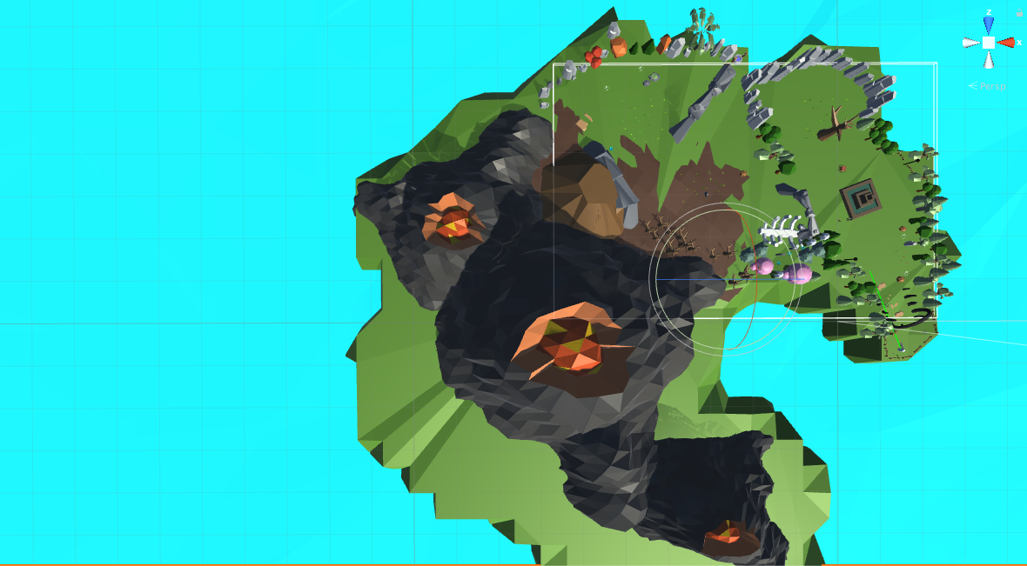

1. Killing the slimes:  
   Only specific bullet can kill one slime. The relationship is shown below. For instance, fire bullet can destroy earth slime, but strengthen fire slime by growing it bigger and increasing its HP. Water slime is capable for destroying the fire bullet.
2. Boss:  
   Player has to walk through the map and look for the boss, a giant slime, in order to clean the current stage.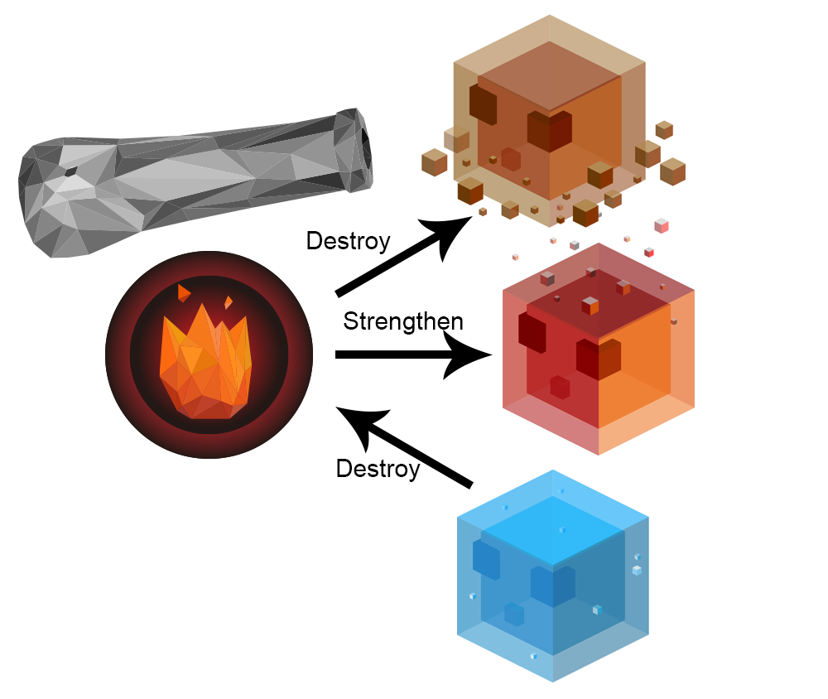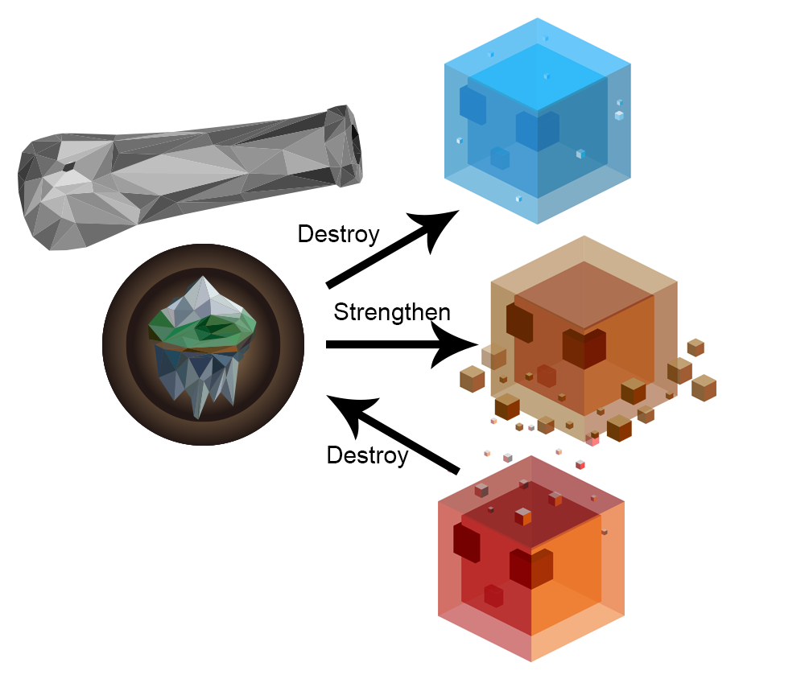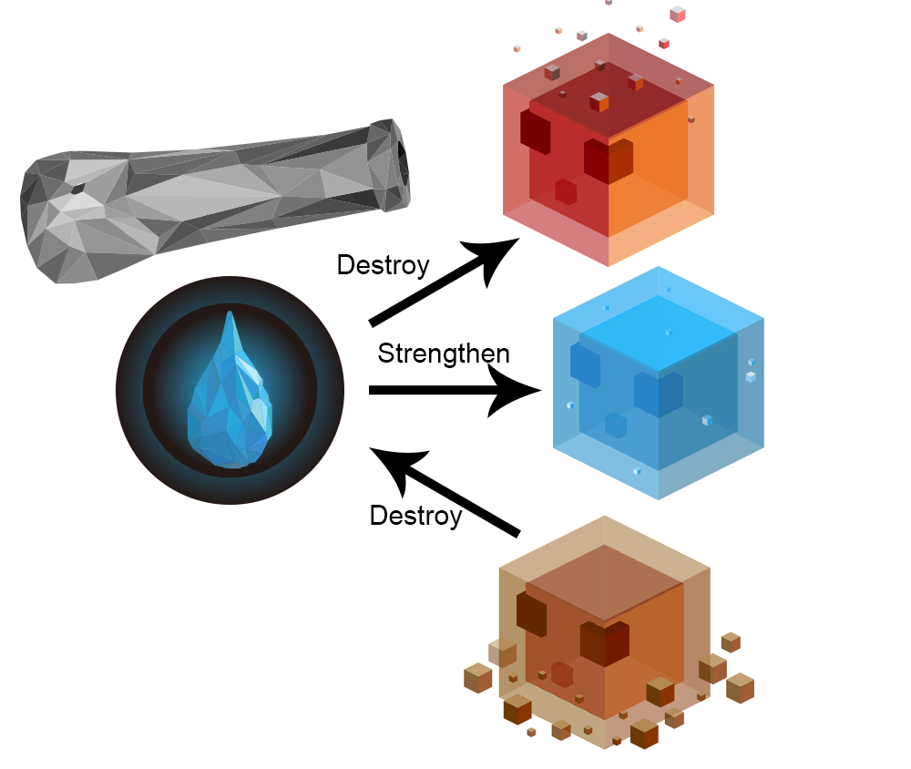

**Control:**

1. WASD to control player movement. R to reload the bullet.
2. Mouse movement controls view direction. Mouse click controls shooting.
3. ESC to leave the game.

**Slime AI:**

1. Spawn from specific zones - most of the slimes only spawn in specific regions.
2. Dynamic pathfinding - if player entered their view area, they will trace and attack the player.
3. Group dynamic - Balance their position when they are sit too crowded.

**Reflections**

Comparing with the phase 1 proposal, we did not include the features of collecting elements. In our game world, there is over fifty seperate objects with different properties. That’s quite wasting time to define them into collectable objects and united properties. But we decide to add something more challenging. Since we decide to unit the same style, most of the game objects are made by ourselves, such as the slime, island, object texture and distribution, 2D images, etc. We study extra practise on making the animation and texture generation. Also, our slime design are also spent a lot of time. We try to visualize what we learnt on lesson into the game, such as group dynamic.